- An email will have been delivered to Yr 9 Students by the school from noreply@sims.co.uk. It will look similar to the one below.

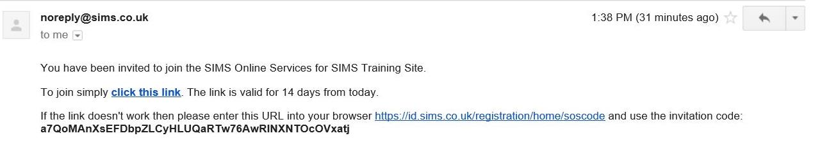

- This should take students to the sign in below - Students should be instructed sign in using OFFICE 365 and sign in with their usual log in.
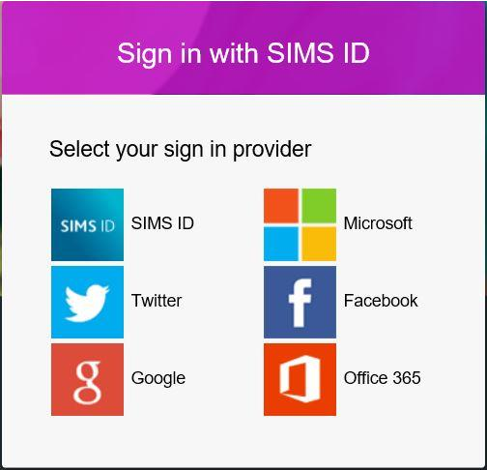

(FIRST TIME USERS ONLY)Once students have logged in using OFFICE 365 they will need to enter the code provided in the registration email into the Invitation Code field.

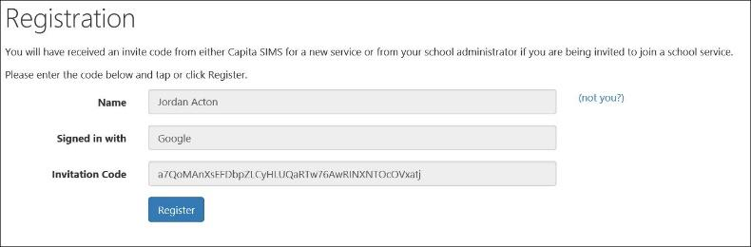

(FIRST TIME USERS ONLY) Students will then need to verify the account by answering a security question.

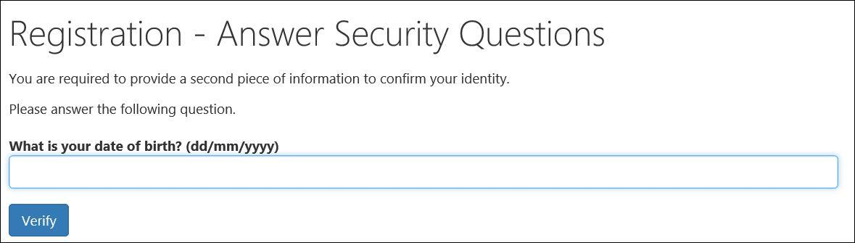

- Students are then required to log into the account to gain access to the active plan. Students need to click on a link in the email from Mr Bendall to www.sims-options.co.uk

Students are only shown their own course choices screen and no personal details are displayed.

Any notes added in the plan definition screen will be displayed.

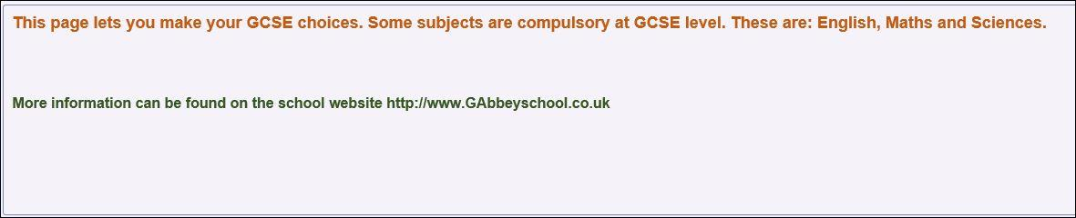

- Students then make their choices by clicking on the course item from the screens displayed.

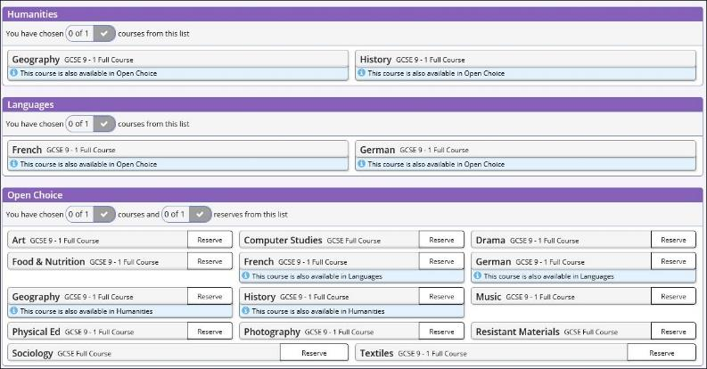

Any requirements or restrictions defined in the relevant plan will be enforced here.

Selections are displayed to the right of the screen and the order of preference can be changed by clicking on the course name and then clicking on which course they wish it to take the place of. Options will move the other courses down a level of preference by default.

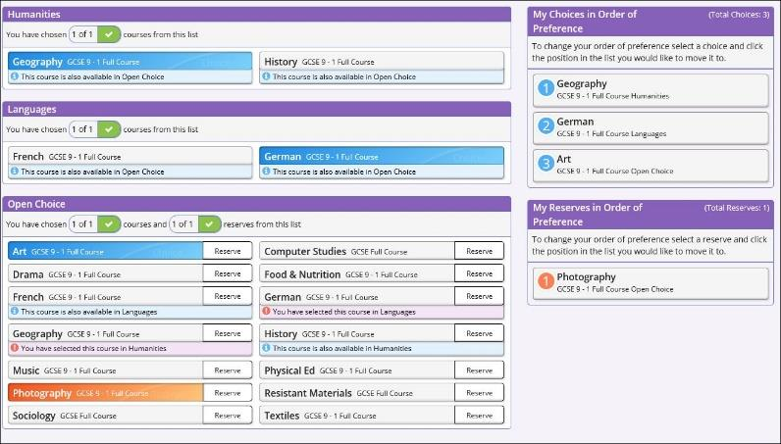

- Comments can be added by the student in the Student comment field at the bottom of the page.

- When all selections have been made the choices should be saved by clicking the save icon to the top left and the student should then sign out of Options Online.

